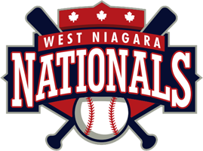

Code of Conduct-Players

- I will attend every practice and game that I can, and will notify my coach if I cannot.
- I will do my best to listen, learn and follow direction from my coaches.
- I will never abuse, mistreat or mishandle any West Niagara league equipment or property.
- I will treat my coaches, other players, officials and fans with respect regardless of race, gender, creed, or abilities, and I will expect to be treated accordingly.
- I will NEVER question an Umpires Call.
- I will encourage my parents to be involved with my team in some capacity because it is important to me.
- I will remember that youth baseball is an opportunity to learn and have fun.
- I will be in full uniform, with all my equipment for each game. Proper uniform pants, socks, shirt and hat . Shirts are to be tucked in and proper protective gear worn at all times.
I have read and understand this Code of Conduct
Name _________________________ Signature _____________________
(please print)

